Analytics Dashboard
Step by Step guide to make HubSpot Analytics guide
Click on "Reporting"
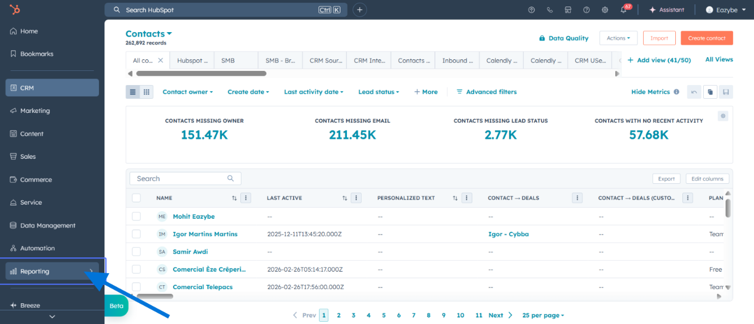
Click on "Reports"
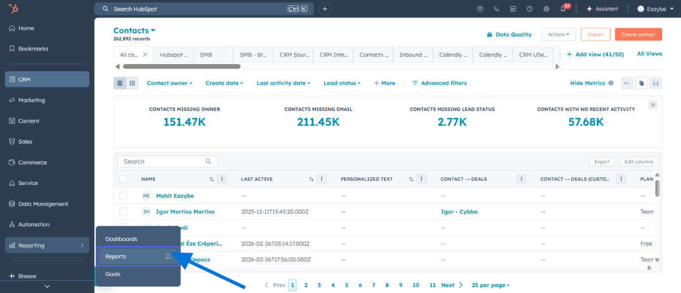
Tab Name: Reports
Click on "Create"
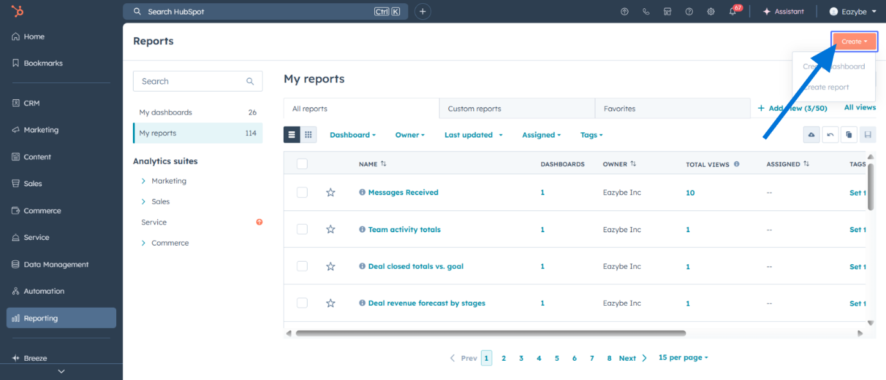
Click on "Create report"
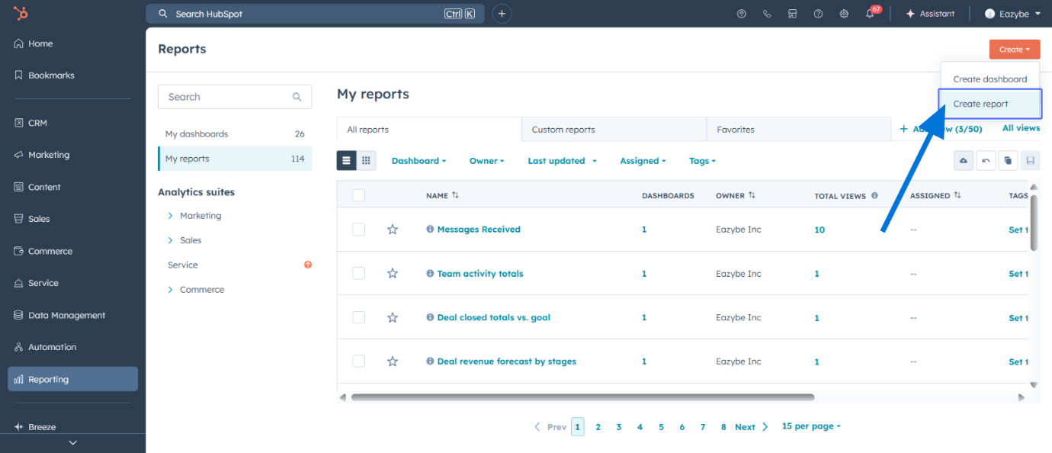
Tab Name: Create Report | HubSpot
Click on "Next"
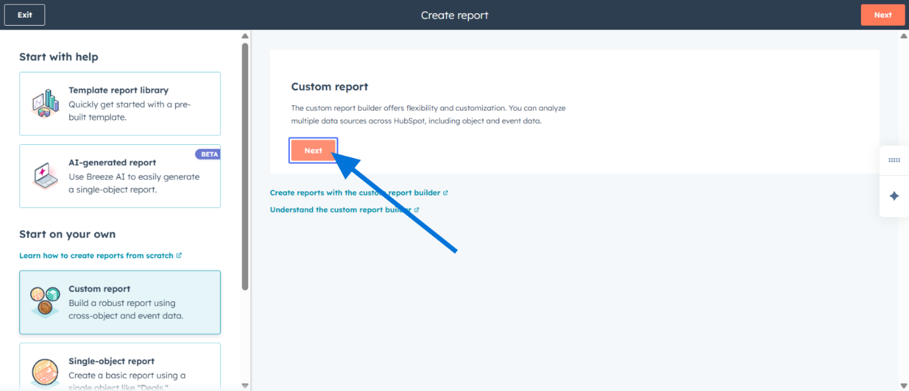
Tab Name: Custom Report Builder
Turn on " Add more data sources "
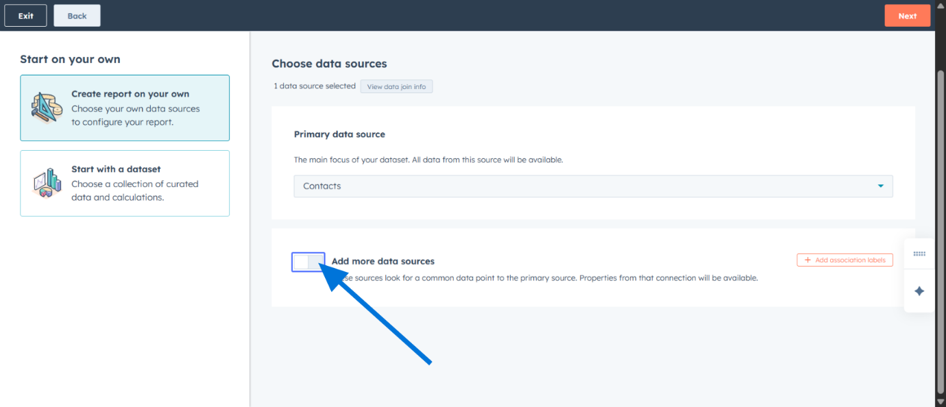
Click on "Next"
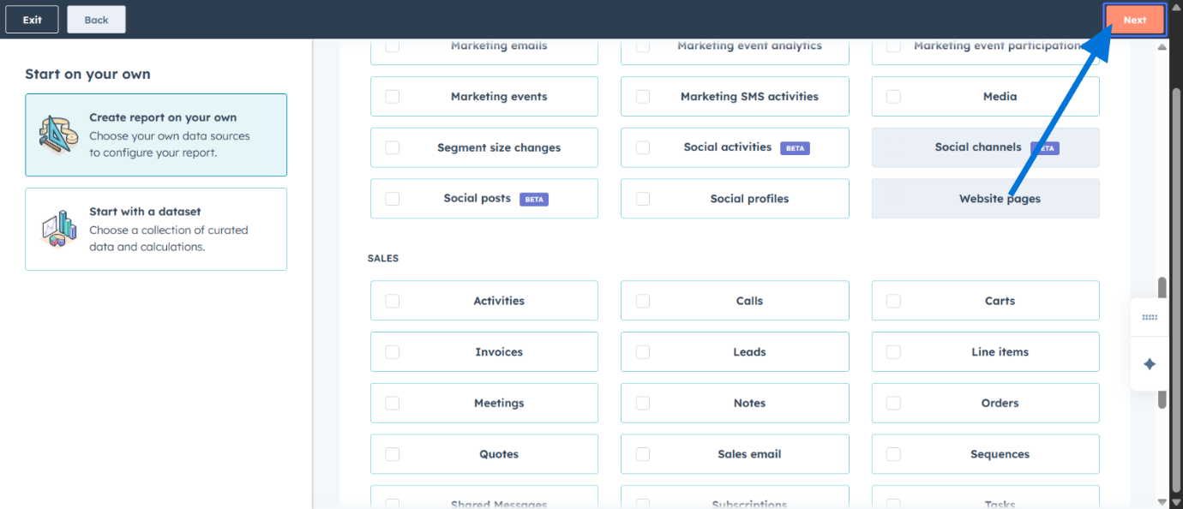

Search for the data source.
( You can choose any data sources of your choice like :
- Average Response Time
- Client Replied
- Current Label
- Current Main Label
- Current Sub Label
- First Response Time
- Follow-ups
- Last AI Summary
- Last Message send by
- Message Received
- Message sent
- Message you got
- Message you sent
- Time Since Last Client Message
- Total Messages )
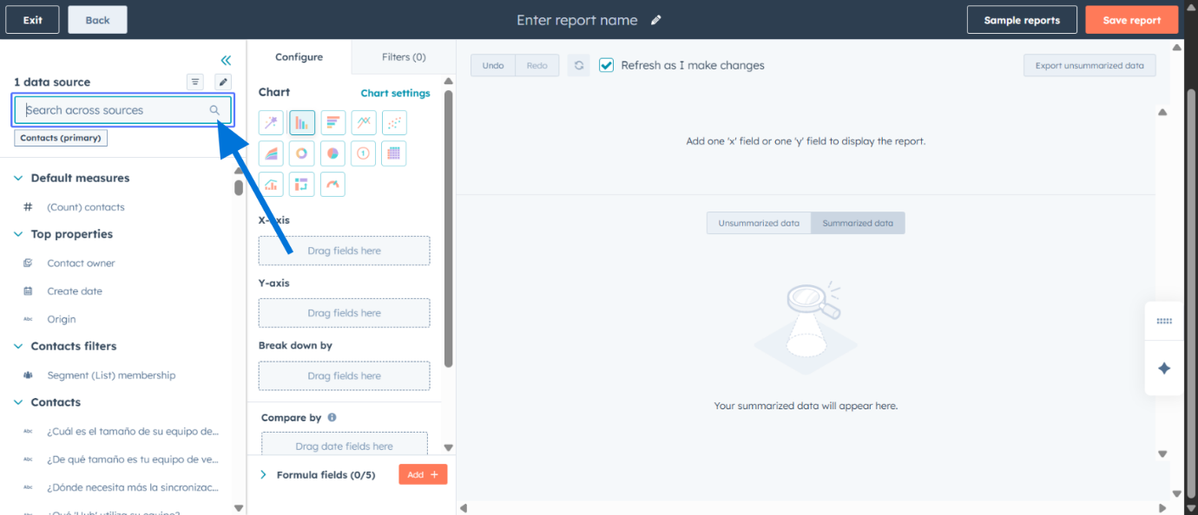
Click on the desired data source and drag to the axis based on the requirement eg. "Total Messages"
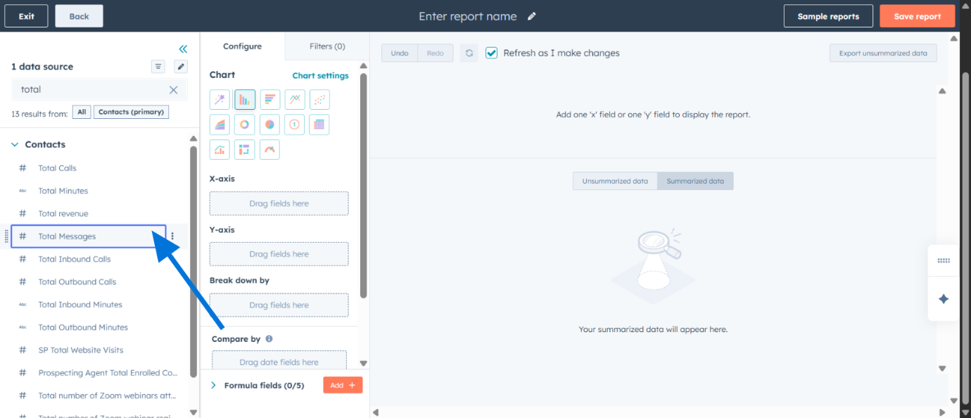
And so on drag and drop the required data sources based on the dashboard requirement.
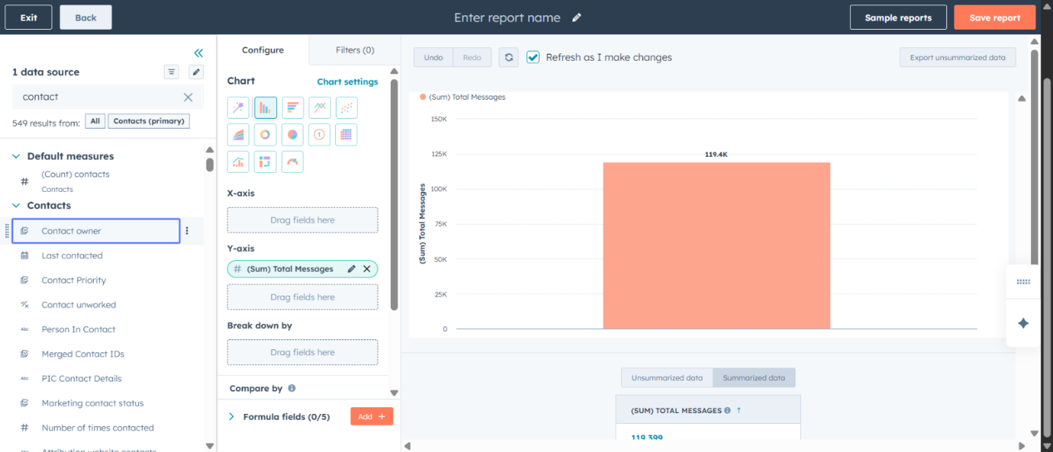
Then click on Save report and your analytical dashboard is ready.
